***ASSIGNMENT NO 3***

***NAME: HAFIZ MUHAMMAD***

***ROLL No: L1F23BSSE0010***

***Task 1:***

<!DOCTYPE html>

<html lang="en">

<head>

  <meta charset="UTF-8">

  <title>Image Changer</title>

  <style>

    #myImage {

      width: 300px;

      border: 4px solid #333;

      transition: transform 0.3s ease;

    }

    button {

      margin-top: 20px;

      padding: 10px 20px;

    }

  </style>

</head>

<body>

  <h2>Image Attribute Change on Events</h2>

  <img

    id="myImage"

    src="WhatsApp Image 2025-06-06 at 21.36.19_eaf659aa.jpg"

    alt="First Image">

  <br>

  <button id="changeBtn">Change Image</button>

  <script>

    const image = document.getElementById('myImage');

    const button = document.getElementById('changeBtn');

    button.addEventListener('click', function () {

      image.src = "WhatsApp Image 2025-06-06 at 21.37.08_40fce2c8.jpg";

      image.alt = "Second Image";

    });

    image.addEventListener('mouseover', function () {

      image.style.transform = "scale(1.1)";

    });

    image.addEventListener('mouseout', function () {

      image.style.transform = "scale(1)";

    });

  </script>

</body>

</html>

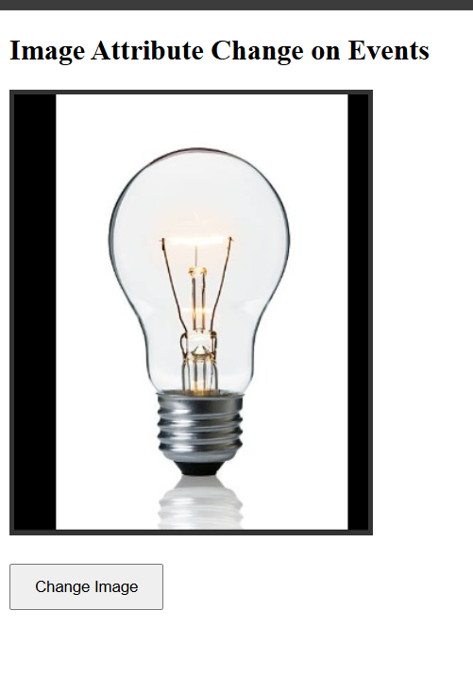

After clicking the change image

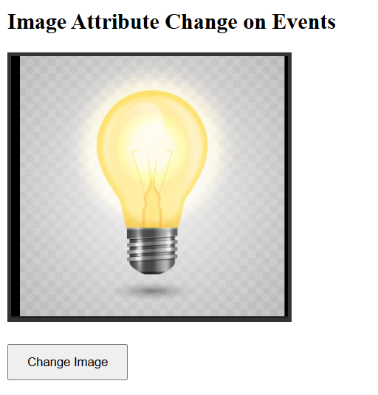

***Task 2:***

<!DOCTYPE html>

<html lang="en">

<head>

  <meta charset="UTF-8">

  <title> Dynamic List</title>

  <style>

    body {

      font-family: Arial, sans-serif;

      padding: 30px;

    }

    ul {

      list-style-type: none;

      padding: 0;

    }

    li {

      background-color: #f0f0f0;

      padding: 10px;

      margin: 5px 0;

      cursor: pointer;

      transition: background-color 0.2s;

    }

    li:hover {

      background-color: #d0e0ff;

    }

  </style>

</head>

<body>

  <h2>Click Any Item to Change Its Text</h2>

  <ul id="itemList">

    <li>Item 1</li>

    <li>Item 2</li>

    <li>Item 3</li>

    <li>Item 4</li>

  </ul>

  <script>

    const list = document.getElementById("itemList");

    list.addEventListener("click", function(event) {

      if (event.target.tagName === "LI") {

        event.target.textContent = "✅ Item has been changed!";

      }

    });

  </script>

</body>

</html>

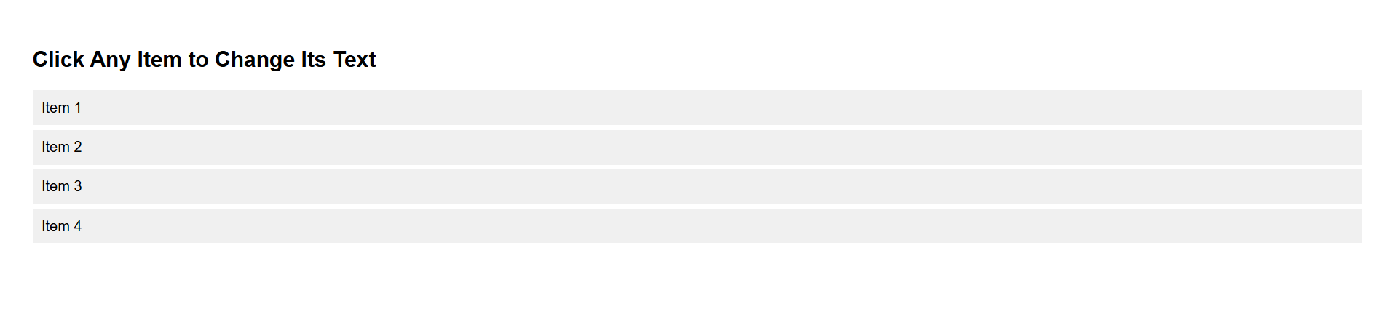

**After clicking**

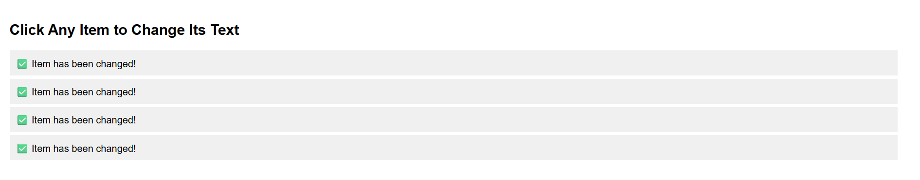

***Task 3:***

<!DOCTYPE html>

<html lang="en">

<head>

  <meta charset="UTF-8">

  <title>Dynamic Element Adder</title>

  <style>

    body {

      font-family: Arial, sans-serif;

      padding: 30px;

    }

    button {

      padding: 10px 20px;

      font-size: 16px;

      cursor: pointer;

    }

    .content-container {

      margin-top: 30px;

    }

    .content-block {

      margin-bottom: 20px;

      padding: 10px;

      background-color: #f5f5f5;

      border-left: 5px solid #007BFF;

    }

  </style>

</head>

<body>

  <h2>Add Headings and Paragraphs</h2>

  <button id="addButton">Add Element</button>

  <div class="content-container" id="contentContainer"></div>

  <script>

    document.getElementById("addButton").addEventListener("click", function() {

      const headingLevel = prompt("Enter heading level h1, h2, h3:");

      const headingText = prompt("Enter text for the heading:");

      const paragraphText = prompt("Enter paragraph text:");

      if (!/^h[1-6]$/.test(headingLevel)) {

        alert("Invalid heading level. Please enter h1 to h6.");

        return;

      }

      const heading = document.createElement(headingLevel);

      heading.textContent = headingText;

      const paragraph = document.createElement("p");

      paragraph.textContent = paragraphText;

      const block = document.createElement("div");

      block.className = "content-block";

      block.appendChild(heading);

      block.appendChild(paragraph);

      document.getElementById("contentContainer").appendChild(block);

    });

  </script>

</body>

</html>

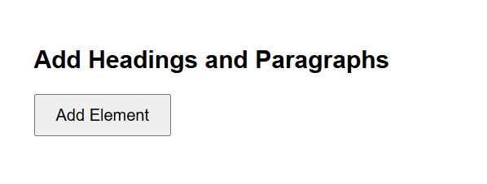

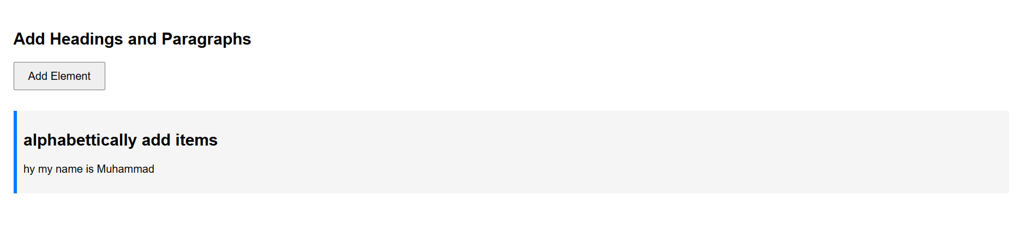

***Task 4:***

